**What are three conclusions we can make about Kickstarter campaigns given the provided data?**

1. As it can be seen in the *1st bar chart*, we have created a table and graphical representation between project categories and project state for each country. In general, the analysis indicates that most of the projects succeeded in Theater where the number of counts was 893, while Music was in the 2nd place with 540 success counts. However, if we think about success rate, the bar graphs clearly shows that the projects in Music category found 90% success, whereas it was 70% in Theater. Overall, the risk of failure in the Theater is a little higher than in the Music category. It is also important to look at the numbers of Journalism where none of the projects( out of 24) found success.

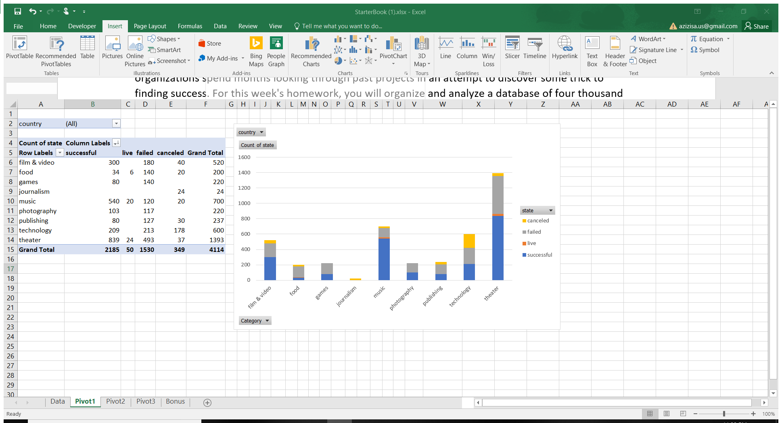

1. In the 2nd chart, we went one step deeper in our analysis to see the project subcategories and their state counts. Obviously, the Theatre plays were the most popular among all other subcategories, but they came along with good amount of failures as well. It is worth looking at the trends of the following projects: Documentary, Rock music, and Hardware . The chart indicates that they found 100% positive outcome.

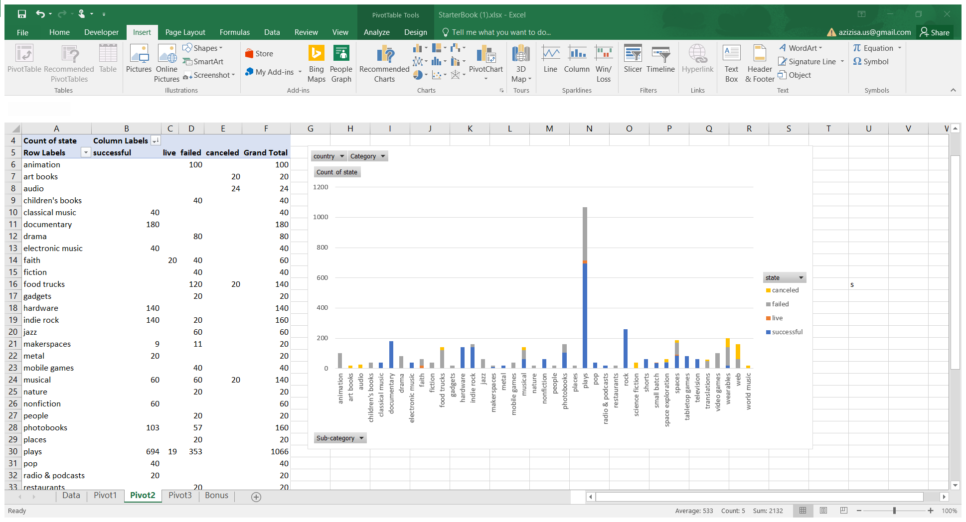

1. Our 3rd analysis answers the question: when is the best time to start new projects with the high probability success? Most of the projects found success between March and May. Thereafter, starting from May, the number of project failures started to rise, at the same time the success counts of the projects decreased. Going Back to Jan & Feb, It was also the best time for the kickstarters, the number of successful projects increased and the number of failures dropped.

**What are some of the limitations of this dataset?**

There are many possible limitations depend on the data design, the sample size, the time of sampling, the way of data collection, the type of sample {convenience non parametric or parametric}, stratifications or not, availability, convenience settings and ect.

Our analysis may have Impact limitations. Even if our study has strong design and excellent graphical representation, it suffers from limited impact from factors such as a strong regional focus, being too project-specific, or the field being only conducive to incremental findings.

**What are some other possible tables/graphs that we could create?**

We could have created pie chart to see the project state for each category in terms of percentages.

Scatter plot showing different State attributes with different colors as it was conditionally highlighted in the dataset.